Uncovering the gaming industry’s hidden gems ; A comprehensive analysis of video games sales

1. **INTRODUCTION**
   1. Overview

This data set contains a list of video games sales greater than 100,000 copies.

* 1. Purpose

Playing video games can improves ones cognitive skills.

1. **Problem definition and Design thinking**
   1. Empathy map

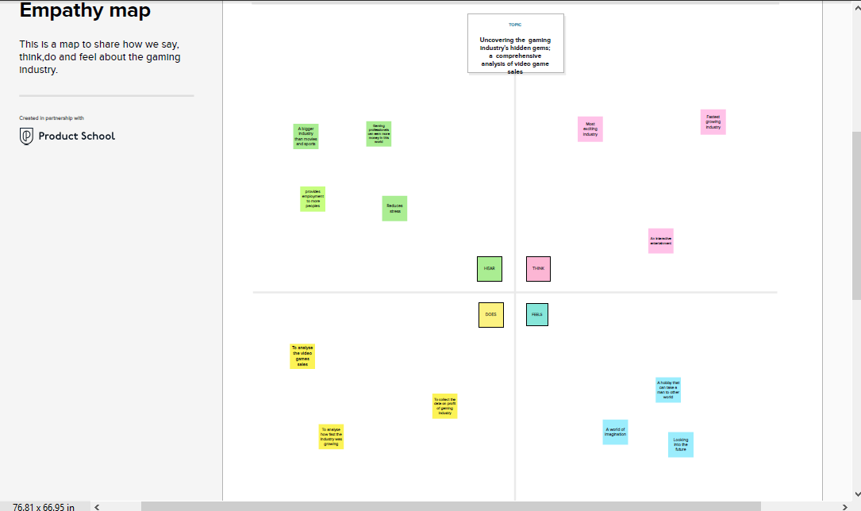

* 1. Ideation and brain storming map

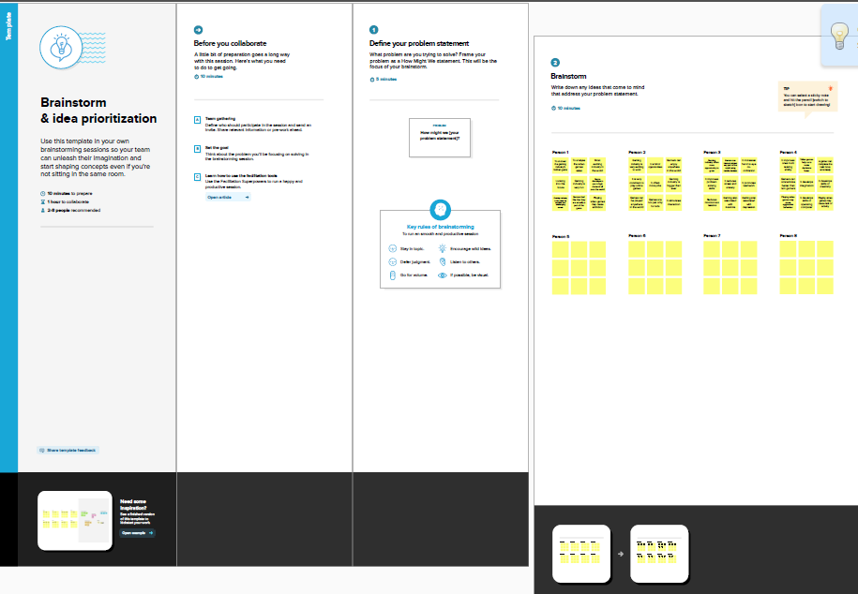

1. **RESULT**

This data may include information about the number of units sold, the retail price, and the platforms on which the games are played. Once the data has been collected , it is typically analyzed using **tableau.**

The publisher **Nintendo**  has sales greater than **577.1** (in millions)

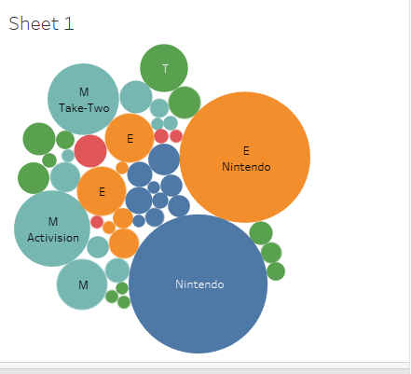

**Wii sports** has NA sales **41.36** (in millions).

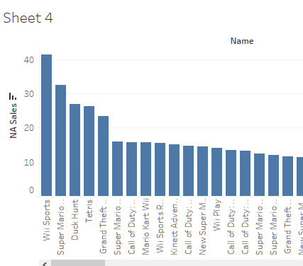

**Wii sports** has global sales more than **82.53** (in millions).

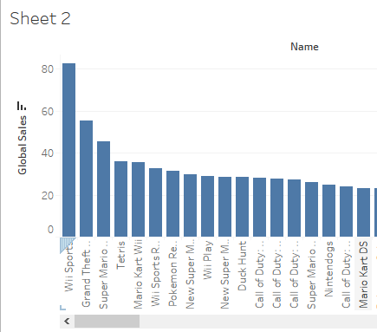

1. **Advantages and disadvantages**

* Video games can be used to help improve test scores, teach life and job skills , improve brain function and encourage physical exercise.
* Playing video games for long period can also lead to poor mental health , including anxiety and disorders and depression.

1. **Applications**

However , the benefits of video games include improved concentration , creativity , memory , languages and team work.

1. **Conclusion**

Therefore, we can conclude that there are so many games in this world .

Gaming industry is bigger than ever. It is very fun and exiciting to work.

1. **Future scope**

Gaming industry is full of opportunities. It has an array of career choices to offer.

Jobs in the gaming industry

* Video game designer
* Video game artist
* Audio programmer
* Game programmer
* Game tester
* Professional gamer
* Game producer